CS547: Advanced Topics in Software Engineering
Assessed Assignment
for
Assignment 1 Part 2
Prepared by Ali Nasir & Hamish Hartley
Group = CS547Assignment1Part2Group38
Submitted to: Marc Roper
Table of Contents

Contents
1. Implementation of the Genetic Algorithm (GA) 1
1.1 Representation 1
1.2 Fitness Function 1
1.3 Mutation 1
1.4 Crossover 1
1.5 Selection 1
1.6 Implementation 1
1.7 Results and Evaluation: Small Problem 2
1.8 Results and Evaluation: Big Problem 2

Implementation of the Genetic Algorithm (GA)

Representation
A subset of the test case (t1, t2, t3, etc.) is used to represent each individual in the test set. In the test instance, 1 denotes inclusion and 0 denotes exclusion. It is appropriate to use a binary representation since every test case is either chosen or not. This enables the GA to directly choose a subset of tests instead of ranking them.

Fitness Function
The fitness function used in this project is based:
- Maximizing Fault Coverage: The fitness function calculates the total fault coverage by summing the number of unique faults detected by the selected tests. Since the goal is to maximize fault coverage, it is represented as a positive weight
- Minimizing Execution Time: The fitness function also calculates the total execution time of the selected tests by summing their execution times. Since this should be minimized, it is represented as a negative weight.

Mutation
Bit flip mutation is used, which introduces randomness and helps explore the solution space more effectively. This allows the GA to explore new combinations by flipping selected tests on or off.

Crossover
Uniform crossover is used with a probability of 0.5 (50%) as each bit is chosen from either parent with equal probability. This operator helps create diverse offspring.

Selection
The DEAP’s NSGA-II as a selection mechanism is used for multi-objective optimization. It maintains a Pareto front of non-dominated solutions, balancing between fault coverage and execution time.

Implementation
The GA was configured using DEAP framework with the following parameters:
- Number of test: 100
- Population Size: 100
- Number of Generations: 50
- Crossover Probability: 0.7
- Mutation Probability: 0.2
Each generation produces a new population through crossover, mutation, and selection by NSGA-II to maintain a Pareto front of non-dominated solutions.

Results and Evaluation: Small Dataset

Genetic Algorithm
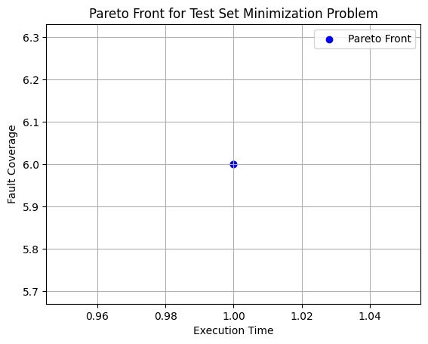
|

Random Search

Results and Evaluation: Big Dataset

Genetic Algorithm
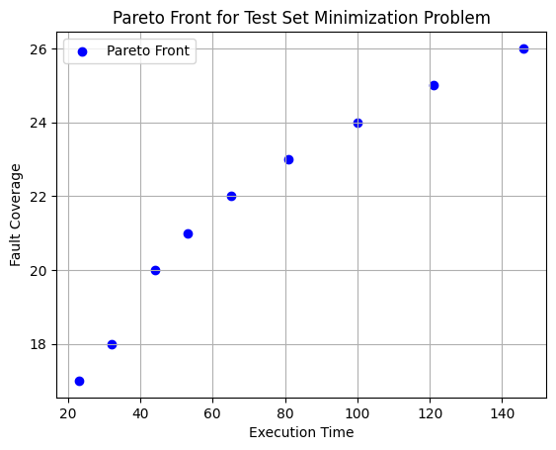

Random Search

